##### *ORA.32 – Display EI Table*

##### *General Information*

?

**EPIC :** HI Assessment Form **Story Point :**

**Linked UC document :** [Identification name of the UC document linked with the US]

**Author :** Chakir BAHAMMOU

**Product Owner :** Fabienne De La Touanne **Business Value : Medium**

##### *Details*

**As a** User

**I want**  To add EI to the list of EI related to my Applied Risk

**So that**  I can define the EI scope of the Intrinsic Risk

##### Business Context

* *Process* :- *Intrinsic Risk -> External Incident*
* *Context : - Risk Assessment*
* *Identified Impacts : -*
* *Prerequisite : -*
* *Entities : - Applied Risk, Risk Assessment, External Incident*

##### *User Interface*

##### Mock-up 1 – Risk Assessment 🡪 Intrinsic Risk 🡪 External Incidents Page

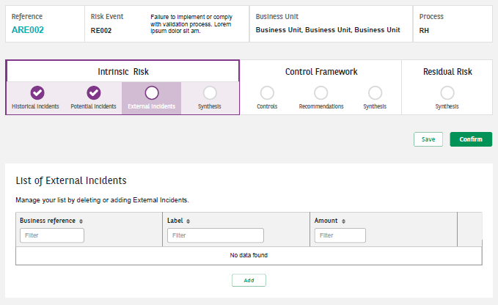

##### Mock-up 2 – Risk Assessment 🡪 Intrinsic Risk 🡪 External Incidents Page 🡪 List of External Incident

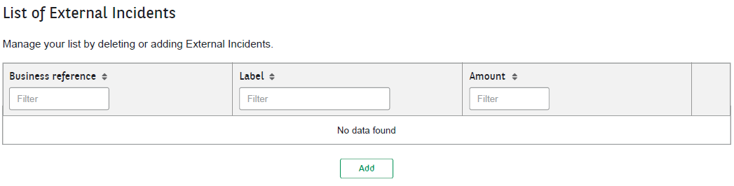

This table is a part of the EI Assessment Form. It can be displayed by clicking on the “**External Incidents**” card.

##### Mock-up 3 – Risk Assessment 🡪 Intrinsic Risk 🡪 External Incidents Page 🡪 List of External Incident 🡪 Add External Incident

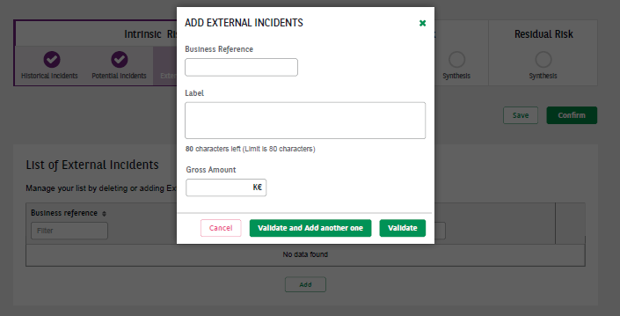

##### Acceptance Criteria

The following business rules should be implemented. The “UI Guideline” must be respected.

|  |  |  |  |
| --- | --- | --- | --- |
| **#** | **Business rules reference** | **Description** | **Mock-up** |
| **1** | **RG.RAS.GUI** | The table is named “List of External incidents” and is composed of the following columns :   * “Business Reference” : The Id of the EI * “Label : The name of the EI * “Gross Amount” : The gross global amount | 2 |
| **2** | **RG.RAS.GUI** | The sentence “Manage your list by deleting or adding new External Incidents.” is written above the table. | 2 |
| **3** | **RG.RAS.GUI** | In the table, the External Incidents are ordered chronologically by default, from newest to oldest | 2 |
| **4** | **RG.RAS.GUI** | If a value of the table is too large to be displayed, it is cut and the full value is visible using a tool tip | 2 |
| **5** | **RG.RAS.GUI** | Each line can be deleted (directly in the database) by using a trash-bin. A confirmation pop-up is used before deleting. (see “UI Guideline”) | 2 |
| **6** | **RG.RAS.GUI** | A button “Add” is displayed in the bottom of the table (see “UI Guideline”) | 2 |
| **7** | **RG.RAS.GUI** | When clicking on the “Add” button a pop-in with a EI creation form is displayed with the following fields:   * “Business Reference” Mandatory Text field AN 13 * “Label” Mandatory Text field AN 80 * “Gross Amount” Mandatory Text field N 22 **(can be a negative value)** | 3 |
| **9** | **RG.RAS.GUI** | If a mandatory field is empty when the form is submitted, a red error message is displayed right under the related field :  “This field is required” | 3 |
| **10** | **RG.RAS.GUI** | On “Validate” click, if all mandatory fields are well filled, a line is added to the EI table (and stored in the database), and the popin is closed. | 3 |
| **11** | **RG.RAS.GUI** | On “Validate and Add a new one” click, if all mandatory fields are well filled, a line is added to the EI table (and stored in the database), and the popin stays opened and the pop in fields are cleared. | 3 |
| **12** | **RG.RAS.OBJ** | Before creating a new EI in the database, a control is made on the EI Business Reference to avoid/prevent the user from creating duplications.  If the Business Reference of a EI is already linked to the Risk Assessment, a red error message is displayed right under the related field :  “A EI with the same Business Reference is already linked to the current assessment” | 2 |
| **13** | **RG.RAS.GUI** | On “Cancel” click, the popin is closed without any modification on the EI table | 2 |
| **14** | **RG.RAS.GUI** | On “Save” click, the form is saved in the database. | 1 |
| **15** | **RG.RAS.GUI** | On page load, the table is filled with the previously added EI (stored in the database) | 1 |

##### ANNEXE

Global View of the Historical Incidents screen.

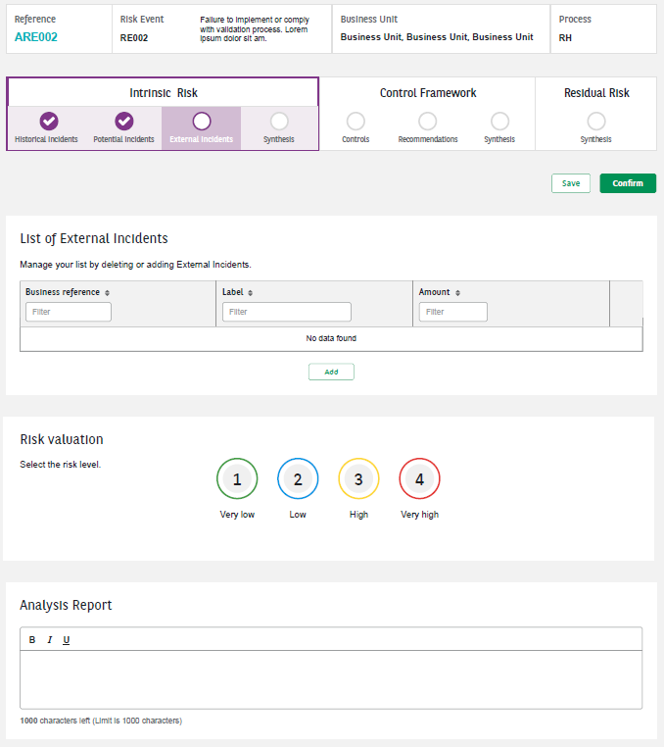

The view is an indication of the structure of the screen. The UI Guidelines and the specifications should be respected.

##### Acceptance Tests

|  |
| --- |
| Background:    Frank : a User    **PERSONAS TO BE DETERMINED** |

**Narrative:**

**As a** User

**In order to** Explain my Intrinsic Risk Assessment

**I want** **to** link relevant EI to the Assessment

|  |  |
| --- | --- |
| **GIVEN** | There is an assessment of an Applied Risk:   * Assessment Ref : RIA00001 * Applied Risk : AR0025 * Historical Incident List related to the AR0025 is :   + IE001 - External Incident 1 - 1000   + IE004 - External Incident 4 - 4000 |
| **WHEN** | Frank wants to add a HI to the list :   * + IE0012 - External Incident 12 – 12000 |
| **THEN** | * The Historical Incident List related to the AR0025 is :   + IE001 - External Incident 1 - 1000   + IE004 - External Incident 4 - 4000   + IE0012 - External Incident 12 – 12000 |

**Narrative:**

**As a** User

**In order to** Explain my Intrinsic Risk Assessment

**I want** **to** remove the link between the assessment and a non-relevant HI

|  |  |
| --- | --- |
| **GIVEN** | There is an assessment of an Applied Risk:   * Assessment Ref : RIA00001 * Applied Risk : AR0025 * Historical Incident List related to the AR0025 is :   + IE001 - External Incident 1 - 1000   + IE004 - External Incident 4 - 4000   + IE0012 - External Incident 12 – 12000 |
| **WHEN** | Frank wants to remove a HI from the list :   * + IE0012 - External Incident 12 – 12000 |
| **THEN** | * The Historical Incident List related to the AR0025 is :   + IE001 - External Incident 1 - 1000   + IE004 - External Incident 4 - 4000 |